16” Pizza  Date  Meat, Veggie, Supreme or Mexican | $14.99
Fish Dinner  A Delicious fish sandwich served with French fries and a pickle. | $5.99
Gyro Dinner  Served w/fries & a biscuit & coleslaw or gyro sauce. | $5.99
Wings  6pc BBQ, Honey Mustard, Mild or Hot. Ranch or Blue cheese dressing. | $4.50
Tacos  Chicken or Beef. | $1.99 or 3 $4.99

Daily Specials 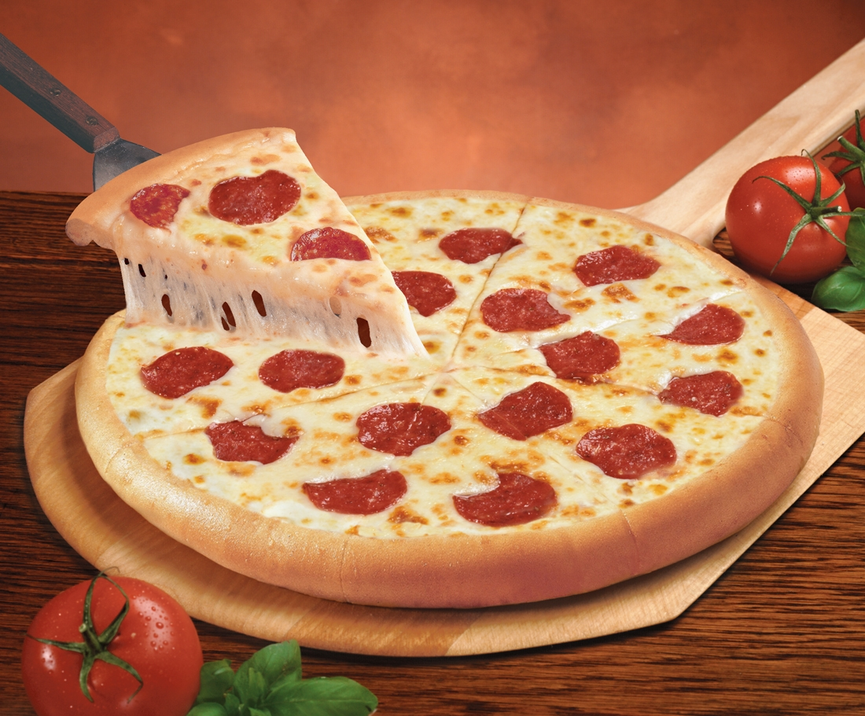
polospizzaandgrill@yahoo.com
Find us on Facebook!

S80W 14401 Schultz Lane
Muskego, WI
Phone: 414-422-1463

Cash only

Polo’s Pizza & Grill

